|  |  |
| --- | --- |
| **Document Name** | Experiential Learning Definition |
| **Description** | Explanation of the Experiential Learning definition adopted by Otago Polytechnic |
| **Purpose** | To define Experiential Learning as it applies to Otago Polytechnic |
| **Audience** | All staff |
| **Owner** | Learning and Teaching |
| **Last Reviewed** | 23 June 2015 |
| **Next Review** | _ |
| **Location** | J:\Shared\Organisation Projects\Designing for Learner Success\03-TEAMS\Learning and Teaching\Experiential Learning\FINAL_Experiential Learning Definition_ABapproved_23 6 15.docx |

***Definitions for OP (to attach to L & T Strategic Framework)***

**Experiential Learning**

***Definition***

Experiential learning is learning through *reflecting* on experience within the context of programmes and courses, including the face-to-face activities, online activities, student-managed activities and authentic work experiences that have been designed to enable learning.

***Further explanation:***

Experiential learning experiences are *designed* to engage learners in an activity and to initiate the reflection process. Learning takes place through a cycle whereby learners reflect on the activity (think about it; asking ‘what?’), explore abstract concepts (ideas, theories, beliefs; asking ‘so what?’) and make connections between theory and the learner’s actual experiences (linking, correlations, relationships; asking ‘now what?’) and apply this learning to new activities or work contexts (take action).

The experiential learning cycle encourages learners to think more deeply, reflect, develop critical-thinking skills, transfer their learning into action and apply what they learned in one situation into another. Experiential learning happens through the learner’s reflection “in” and “on” experiences using analytic skills (investigation and questioning). The cycle includes more than one reflection point. It involves constant reflecting, reinforcing and re-examining to gain a deep understanding. It can occur with or without facilitation by a teacher. See diagram below.

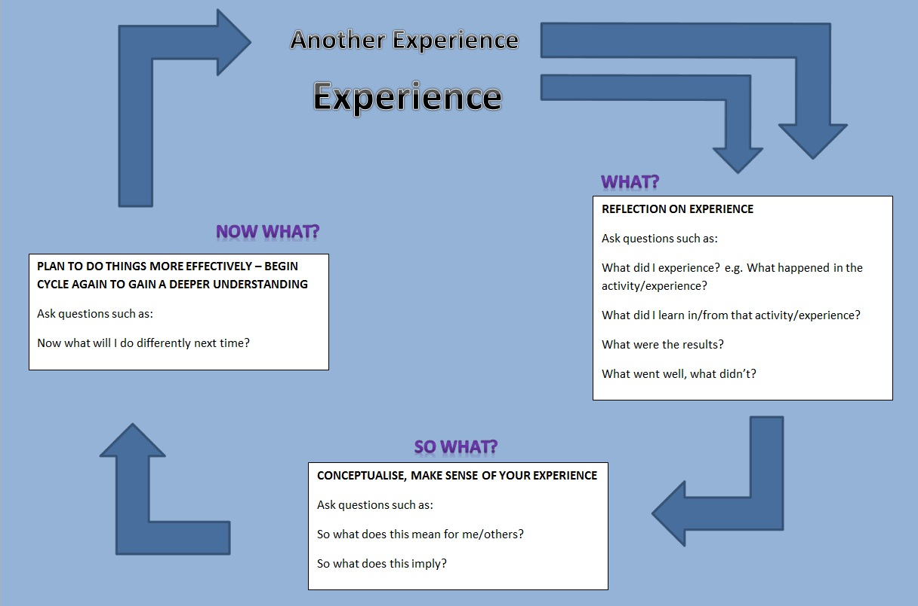

*Lancaster, D. (2015) adapted from Kolb, D. (1984) and Driscoll, J. (1994)*

Learning through everyday experience is not enough; it is the on-going reflective process of multiple cycles of action, reflection and taking action as a result of the reflection that facilitates an individual’s learning. Through this process learners will develop their own understandings and conclusions relevant to them. The learning will be personal to each learner and the teacher cannot predict the learning an individual will take from the experience. Individuals may take very different messages from a single event. When students engage in on-going cycles of experience/activity, reflection, conceptual thinking and identification and application of learning their learning is enhanced. See diagram below showing the repeated cycles of experience, reflection, conceptual thinking and identification and application of learning.

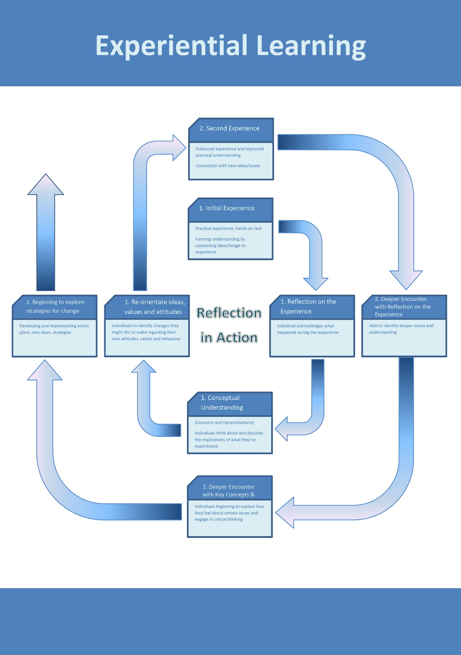

*Law, B. (2006)*

A learning experience is a means to an end, not an end in itself. The essence of effective experiential learning is that the entire process is centred on the learner and not the task, allowing the learner to derive meaning from an experience and developing the learner as an individual.

Teachers can support experiential learning by:

* creating an appropriate learning environment where learners are a able to undertake each element of the experiential learning cycle safely to develop reflection skills and critical thinking skills
* designing a meaningful experience (activity) that will initiate the experiential learning process
* guiding thinking, purposefully questioning and challenging learners’ thinking to develop understanding
* ensuring that any conceptual thinking is progressed to meaningful conclusion and opportunities for improvement identified
* where appropriate, ensuring opportunities for students to plan their own learning outcomes within specific courses such as electives and within specific assessments, e.g. learner managed projects.

**Blended learning**

***Definition***

Learning through a blend of modes including face-to-face, online, authentic work experiences and student-managed learning.

***Further explanation***

All Otago Polytechnic on-campus programmes will be designed to ensure learning opportunities that blend face-to-face learning, on-line learning, authentic work experiences and student-managed learning. While programmes must blend these four modes, individual courses may use single modes or a combination of modes to best facilitate student learning within the course. All learning opportunities will be underpinned by experiential learning.

**Face-to-face** learning is where students are physically present with others involved in the learning process. For example:

* classroom learning experiences
* small group tutorials
* laboratories
* studios
* community experiences
* student projects

**On-line** learning uses electronic technology to deliver learning materials and activities. Students can engage in online learning activities at the same time (synchronous), for example in online tutorials or discussion. Student can engage with online activities in their own time (asynchronous), for example working through modules on Moodle, posting a blog or engaging in a discussion forum. All courses have a Moodle shell through which students access any planned online learning activities.

**Authentic work experiences** cover a wide range of learning opportunities focussed on work. These might be real work experiences or they might be interactive learning activities that have been designed to replicate as much as possible the tasks or activities or settings of real world work. In other words activities that are designed to ‘feel’ like a real work place situation. Examples of authentic work experiences include one or more of the following:

* Supervised placements in workplaces (for example in Health, Social Services or Engineering/Trades programmes)
* Internships
* Volunteer experiences in the community (for example in Art or Occupational Health)
* Industry projects (for example in IT and Engineering)
* Work-based learning (for example in Capable NZ)
* Work place learning (for example in VET nursing)
* Apprenticeships (for example in Carpentry, Electrical Technology)
* Student-delivered services at Otago Polytechnic (eg. Kowhai Centre for counselling students; house building for carpentry students; automotive workshops for automotive engineering students; Technique, and other OP restaurants and cafes for cookery, hospitality and culinary arts students; gardens and nurseries for horticulture; and landscaping projects for internal and external clients).
* Simulations, role plays and case studies (for example in health, engineering trades or business)
* Practical outdoor learning (for example in avalanche, outdoor education and sports programmes)
* Using authentic industry-based documents (eg. In health or business administration)
* Problem or project-based learning (eg electric car project in engineering, Year One Bachelor of Applied Management projects)
* Student projects

Any specific learning activity may combine one or more modes of learning. For example:

* ‘Flipped classrooms’ combine face-to-face and on-line learning. Students are required to engage with online resources on a topic before coming to class to engage in learning activities that help them apply the knowledge and understanding they gained online to the activity they are doing in the classroom.
* Synchronous online learning within a computer laboratory enables students to engage with online materials in a classroom setting with others and gives them immediate access to peer support and discussion.
* Simulations (nursing and welding) combine face-to-face activity in clinical laboratories with electronic technologies that replicate real workplace activities such as assessment of a patient or using a welding machine. Simulations enable students to learn and practice skills in a safe environment.

**Student-managed learning** can be in any mode. It is where the student engages in learning activities without the presence of the teacher and the student is required to self-manage to complete the activity within the expected timeframe. The learning activities may be designed by the teacher but carried out by the student alone or in groups, for example in a student-managed project, asynchronous online learning or preparation of an assessment task. Student-managed learning can also be student-directed whereby the student chooses to explore topics of interest to them as an adjunct to the formal learning designed by the teacher.

**Assessment**

***Definition***

Assessment is at the heart of the learning and teaching process. It is the process of documenting, usually in measurable terms, a student’s performance against explicit learning outcomes and levels of achievement. It involves gathering, analysing, interpreting and using a range of information that provides evidence of a student’s knowledge, skills, attitudes and beliefs, in order to make a valid and reliable judgment about their performance and achievement.

***Further explanation***

The primary purpose of assessment is to improve student’s learning and both students and teachers respond to the information it provides. Good quality teaching practices including clear assessment criteria and standards influence the effectiveness of student learning. Systematic analysis of student performance on assessed tasks can help identify areas of the curriculum that need improvement (CSHS, 2002).

Most students are strongly motivated by assessment and it is therefore a powerful strategic tool for educators to spell out the learning that will be rewarded through effective study (CSHE, 2002). Course learning outcomes should explicitly define what knowledge, understanding or skills students need and the criteria and level they need to achieve. Assessment tasks should match the learning outcomes and enable valid and reliable assessment of student performance and achievement. Through the process of gathering information to find out what students currently know, understand and can do, gaps may be identified between the expected and actual level of achievement. Learning activities can be designed or undertaken to reduce the gap. Carefully designed assessments influence how students approach their study and therefore contribute to the quality of their learning (CSHE, 2002).

Effective assessment should:

1. Help students to learn
2. Be consistent with learning outcomes and learning activities
3. Encourage effective approaches to learning
4. Be diverse to assess a range of different learning outcomes
5. Set clear expectations in advance for students and staff about what is expected in assessment tasks
6. Use assessment tasks that validly and reliably determine the valued learning outcomes
7. Provide detailed, transparent and justifiable criteria for assessment
8. Provide specific and timely feedback to students
9. Sample learning, not overload the student (too much assessment can be counter-productive) but provide opportunities for students to self-monitor, practice and receive feedback
10. Be moderated by others
11. Be authentic (mirror the skills needed in the workplace)

(Centre for Study of Higher Education, 2002)

Assessment data can be gathered informally and ‘of the moment’. Formal assessment ensures consistency in the interpretation of student progress and achievement. Assessments may also be formative or summative.

**Formative assessment** is developmental and is used to guide student learning and progression by giving feedback to help learning and promote further improvement during their ongoing educational journey. Formative assessments do not count towards the final grade and usually occur throughout the period of study. **Summative assessment** is the summary and judgment of student achievement at a particular time and it counts towards the final grade. It also guides student learning but its emphasis is on making decisions on satisfactory completion or readiness to progress to the next level of study. Summative assessments ultimately protect and guarantee academic standards.

**Valid** assessments measure what they are supposed to measure.

**Reliable** assessments can be repeated at another time and in another place and will still measure what they are intended to measure.

Valid and reliable assessments can be achieved through self and peer assessment (formative and summative) as well as through teacher-led assessment process.

**Achievement-based** assessments are measured against assessment criteria and students can achieve the same things at different levels of ability and are graded accordingly.

**Competency-based** assessments are also measured against assessment criteria but no marks are awarded and students receive a pass/complete if they reach the minimum standard or a fail/incomplete if they do not.

**Moderation** is a process that ensures assessments and grades are fair, valid and consistent. Moderation can be undertaken by a colleague of someone external to the organisation.

**Cultural Competence**

The basis for our conscious commitment to cultural competence at Otago Polytechnic is in recognition of New Zealand’s founding agreement, the Treaty of Waitangi, and our partnership with local Rūnaka. This commitment extends to all ethnicities and other definitions of cultures, and we are accepting of people from all cultural groups. We use the word ‘culture’ because;

It implies the pattern of human behavior that includes thoughts, communications, actions, customs, beliefs, values and institutions of a racial, ethnic, religious or social group. The word competence is used because it implies having the capacity to function effectively (Kelley, 2010, p.8.).

We foster a safe learning environment which is inclusive of cultural diversity and supports all students irrespective of ethnicity and gender identity. Staff at Otago Polytechnic are culturally competent, meaning that they:

* Are aware of their own cultural perspectives and attitude towards difference
* Are knowledgeable of diversity and differing perspectives
* Are skillful in communicating and interacting with others across cultures
* Respect diversity.

As stated by the New Zealand Teacher’s Council (n.d. p.2):

Culturally competent teachers are able to use the learner’s culture/s as a building block to learn and teach. They understand how to utilise the learner’s culture/s to aid the teaching and learning process, as well as to facilitate relationships and professional growth.

An important aspect of cultural competence for a teacher/facilitator is, once having identified your own culture and recognised difference, to reframe “the differences so that diversity is not seen as a problem to be solved” (Lindsey, Robins, & Terrell, 2003). Acknowledging differing values, beliefs, cultural practices and perspectives enables supportive learning environments to be created.

Additionally, a priority in OP’s internationalisation strategy is to improve the learner experience for international students. How we are approach learning is flavoured by the cultures we grow up in: educational values, behaviours and skills are acquired through schooling. Students may not be aware that in the learning environment of another culture, their skills, behaviours and expectations may not match those of their teachers, and vice versa (McLean and Ransom, 2005). Effective interaction with students from other ethnicities and gender identity requires an awareness of one's own cultural worldview, a positive attitude towards cultural differences, knowledge of different cultural practices and worldviews, and cross-cultural communication skills.

Culturally responsive teaching and facilitation of learning occurs when teachers/facilitators:

* Develop and embrace a knowledge base about cultural diversity and the reality of the cultural experiences that students bring to the learning environment
* Recognise and own their personal culture and the feelings, beliefs and values that they have about other cultures
* Include ethnic and culturally diverse content in the curriculum
* Demonstrate and build caring, safe, and inviting learning communities that reflect our value of partnership
* Respond to ethnic diversity in the facilitation of learning based on organisational expectations
* Communicate effectively with ethnically diverse students, families, and community partners

(Kelley, 2010)

**References**

* Ako Aotearoa – The National Centre for Tertiary Teaching Excellence. 2010. *Signposts. A professional development resource for new teaching staff in the tertiary sector*. **Retrieved from** <https://akoaotearoa.ac.nz/projects/signposts-professional-development-resource-new-teaching-staff-tertiary-sector>. (Date accessed: 11.5.15)
* Centre for the Study of Higher Education (Melbourne Graduate School of Education) (CSHE). 2002. *Assessing* *Learning in Australian Universities*. Commissioned by the Australian Universities Teaching Committee.  **Retrieved from** <http://www.cshe.unimelb.edu.au/assessinglearning/07/index.html>. (Date Accessed: 11.5.15)
* Driscoll J. (1994) Reflective practice for practise. Senior Nurse. 13 (Jan/Feb), 47 -50
* Kelley, G.J. (2010). *Teacher Activity Guide: The historic journey “yes we can.”* Holland and Associates. **Retrieved from:** <http://thehistoricjourney.org/wp-content/uploads/2011/04/Why-Focus.pdf> (Date Accessed: 11.5.15)
* Kolb, D. A. (1984). Experiential learning: Experience as the source of learning and development. New Jersey: Prentice-Hall.
* Lindsey, R. B., Robins, K. N., Terrell, R. (2003). *Cultural Proficiency: A Manual for School Leaders*. Thousand Oaks, CA: Corwin Press.
* McLean, P., & Ransom, L. (2005). Building Intercultural Competencies. In J. Carroll, & J. Ryan (Eds.) *Teaching International Students* (pp. 45-62). London: Routledge
* New Zealand Teacher's Council. (n.d). *Tātaiako Cultural Competencies for Teachers of Māori Learners : A resource for use with the Graduating Teacher Standards and Registered Teacher Criteria.* New Zealand Teacher's Council. Retrieved from : <http://www.teacherscouncil.govt.nz/required/Tataiako_RTCandGTS.pdf> (Date Accessed: 11.5.15)